**Establishing IPv6 Networks**

Student Version



Huawei Technologies Co., Ltd.

|  |
| --- |
| **Copyright © Huawei Technologies Co., Ltd. 2020. All rights reserved.**  No part of this document may be reproduced or transmitted in any form or by any means without prior written consent of Huawei Technologies Co., Ltd.  **Trademarks and Permissions**  HW_POS_RBG_Vertical-150ppi.png and other Huawei trademarks are trademarks of Huawei Technologies Co., Ltd.  All other trademarks and trade names mentioned in this document are the property of their respective holders.  **Notice**  The purchased products, services and features are stipulated by the contract made between Huawei and the customer. All or part of the products, services and features described in this document may not be within the purchase scope or the usage scope. Unless otherwise specified in the contract, all statements, information, and recommendations in this document are provided "AS IS" without warranties, guarantees or representations of any kind, either express or implied.  The information in this document is subject to change without notice. Every effort has been made in the preparation of this document to ensure accuracy of the contents, but all statements, information, and recommendations in this document do not constitute a warranty of any kind, express or implied. |

|  |  |
| --- | --- |
| Huawei Technologies Co., Ltd. | |
| Address: | Huawei Industrial Base  Bantian, Longgang  Shenzhen 518129  People's Republic of China |
| Website: | <https://e.huawei.com/> |

**Huawei Certification System**

Huawei Certification follows the "platform + ecosystem" development strategy, which is a new collaborative architecture of ICT infrastructure based on "Cloud-Pipe-Terminal". Huawei has set up a complete certification system consisting of three categories: ICT infrastructure certification, platform and service certification, and ICT vertical certification. It is the only certification system that covers all ICT technical fields in the industry. Huawei offers three levels of certification: Huawei Certified ICT Associate (HCIA), Huawei Certified ICT Professional (HCIP), and Huawei Certified ICT Expert (HCIE). Huawei Certification covers all ICT fields and adapts to the industry trend of ICT convergence. With its leading talent development system and certification standards, it is committed to fostering new ICT talent in the digital era, and building a sound ICT talent ecosystem.

Huawei Certified ICT Associate-Datacom (HCIA-Datacom) is designed for Huawei's frontline engineers and anyone who want to understand Huawei's datacom products and technologies. The HCIA-Datacom certification covers routing and switching principles, basic WLAN principles, network security basics, network management and O&M basics, SDN and programmability and automation basics.

The Huawei certification system introduces the industry, fosters innovation, and imparts cutting-edge datacom knowledge.

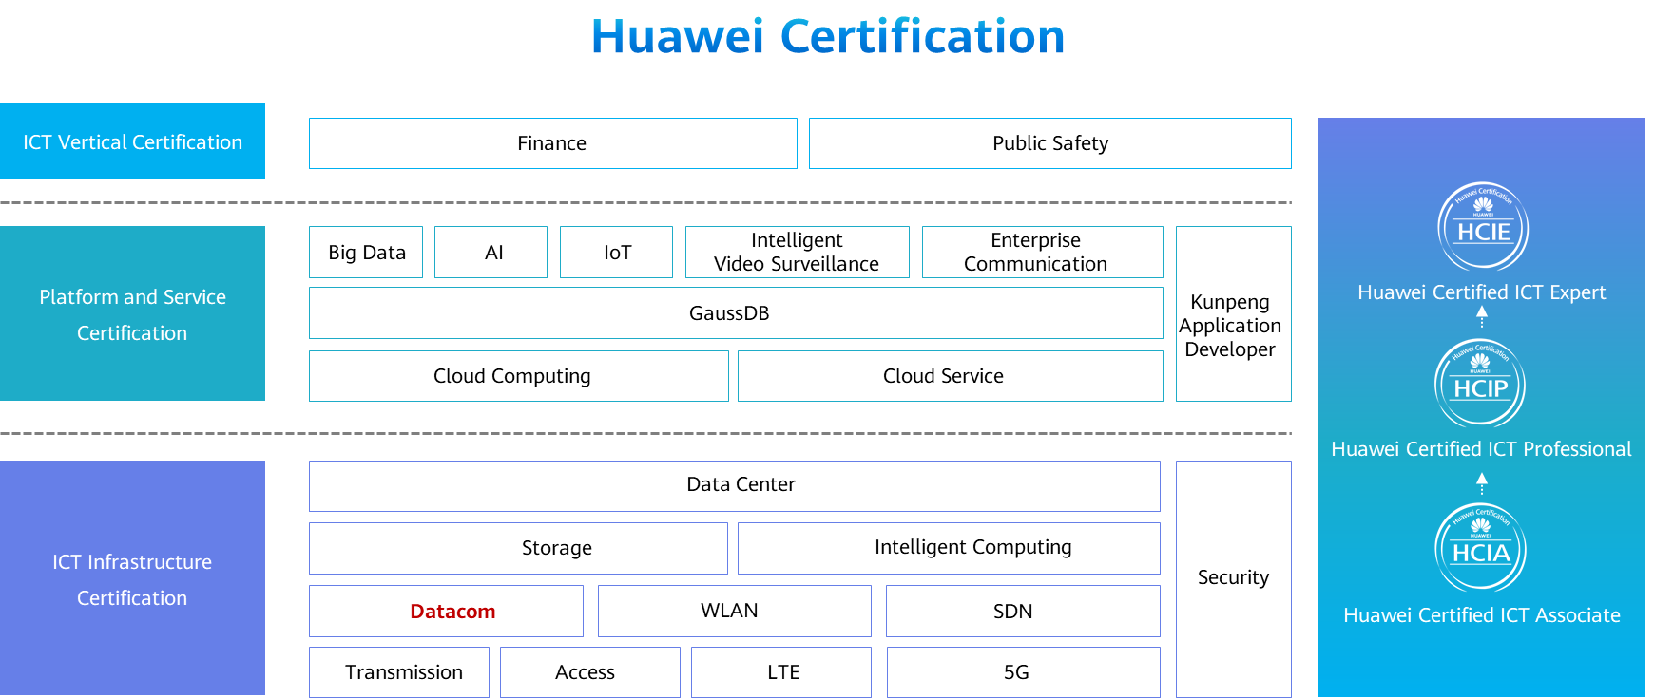

# Establishing IPv6 Networks

## Background

Internet Protocol Version 6 (IPv6) is also called IP Next Generation (IPng). Designed by the Internet Engineering Task Force (IETF), IPv6 is an upgraded version of IPv4.

IPv6 have the following advantages over IPv4:

Infinite address space

Hierarchical address structure

Plug-and-play

Simplified packet header

Security

Mobility

Enhanced QoS features

This chapter describes how to set up an IPv6 network to help you understand the basic principles and address configuration of IPv6.

## Objectives

Upon completion of this task, you will be able to:

Learn how to configure static IPv6 addresses

Learn how to configure a DHCPv6 server

Learn how to configure stateless addresses

Learn how to configure static IPv6 routes

Learn how to view IPv6 information

## Topology

Lab Topology

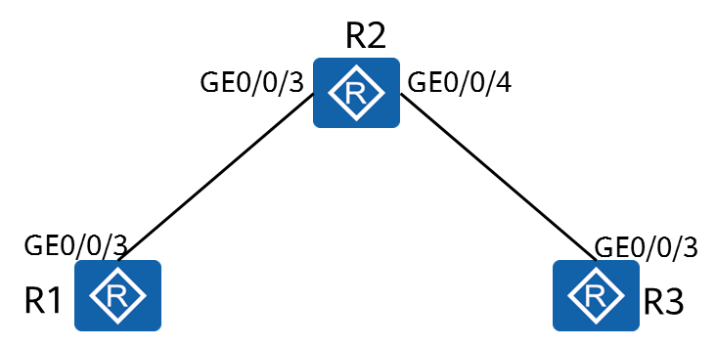

An enterprise needs to deploy IPv6 on its network.

1. Configure static IPv6 addresses for the two interfaces of R2.
2. Configure stateless address auto configuration on GigabitEthernet0/0/3 of R1.
3. Configure an IPv6 address for GigabitEthernet0/0/3 of R3 using DHCPv6.

## Implementation

### Roadmap

1. Configure static IPv6 addresses.
2. Configure DHCPv6.
3. Configure IPv6 stateless address allocation.
4. Display IPv6 addresses.

### Procedure

Complete basic device configuration.

# Name the devices.

The details are not provided here.

Configure IPv6 functions on the devices and interfaces.

# Enable IPv6 globally.

[R1]

The **ipv6** command enables the device to forward IPv6 unicast packets, including sending and receiving local IPv6 packets.

[R2]

[R3]

# Enable IPv6 on the interface.

[R1]interface GigabitEthernet 0/0/3

The **ipv6 enable** command enables the IPv6 function on an interface.

[R2]interface GigabitEthernet 0/0/3

[R2]interface GigabitEthernet 0/0/4

[R3]interface GigabitEthernet 0/0/3

Configure a link-local address for the interface and test the configuration.

# Configure an interface to automatically generate a link-local address.

[R1]interface GigabitEthernet 0/0/3

The **ipv6 address auto link-local** command enables the generation of a link-local address for an interface.

Only one link-local address can be configured for each interface. To prevent link-local address conflict, automatically generated link-local addresses are recommended. After an IPv6 global unicast address is configured for an interface, a link-local address will be automatically generated.

[R2]interface GigabitEthernet 0/0/3

[R2]interface GigabitEthernet 0/0/4

[R3]interface GigabitEthernet 0/0/3

# Display the IPv6 status of the interface and test the connectivity.

<R1>display ipv6 interface GigabitEthernet 0/0/3

GigabitEthernet0/0/3 current state : **UP**

IPv6 protocol current state : **UP** //The physical and protocol status is Up.

IPv6 is enabled, link-local address is **FE80::2E0:FCFF:FE4D:355** //The link-local address for the interface has been generated.

No global unicast address configured

Joined group address(es):

FF02::1:FF4D:355

FF02::2

FF02::1

MTU is 1500 bytes

ND DAD is enabled, number of DAD attempts: 1

ND reachable time is 30000 milliseconds

ND retransmit interval is 1000 milliseconds

Hosts use stateless autoconfig for addresses

<R2>display ipv6 interface GigabitEthernet 0/0/3

GigabitEthernet0/0/3 current state : UP

IPv6 protocol current state : UP

IPv6 is enabled, link-local address is FE80::2E0:FCFF:FE12:6486

No global unicast address configured

Joined group address(es):

FF02::1:FF12:6486

FF02::2

FF02::1

MTU is 1500 bytes

ND DAD is enabled, number of DAD attempts: 1

ND reachable time is 30000 milliseconds

ND retransmit interval is 1000 milliseconds

Hosts use stateless autoconfig for addresses

<R2>display ipv6 interface GigabitEthernet 0/0/4

GigabitEthernet0/0/4 current state : UP

IPv6 protocol current state : UP

IPv6 is enabled, link-local address is FE80::2E0:FCFF:FE12:6487

No global unicast address configured

Joined group address(es):

FF02::1:FF12:6487

FF02::2

FF02::1

MTU is 1500 bytes

ND DAD is enabled, number of DAD attempts: 1

ND reachable time is 30000 milliseconds

ND retransmit interval is 1000 milliseconds

Hosts use stateless autoconfig for addresses

<R3>display ipv6 interface GigabitEthernet 0/0/3

GigabitEthernet0/0/4 current state : UP

IPv6 protocol current state : UP

IPv6 is enabled, link-local address is FE80::2E0:FCFF:FE3C:5133

No global unicast address configured

Joined group address(es):

FF02::1:FF3C:5133

FF02::2

FF02::1

MTU is 1500 bytes

ND DAD is enabled, number of DAD attempts: 1

ND reachable time is 30000 milliseconds

ND retransmit interval is 1000 milliseconds

Hosts use stateless autoconfig for addresses

# Test network connectivity between R1 and R2.

<R1>ping ipv6 FE80::2E0:FCFF:FE12:6486 -i GigabitEthernet 0/0/3

PING FE80::2E0:FCFF:FE12:6486 : 56 data bytes, press CTRL\_C to break

Reply from FE80::2E0:FCFF:FE12:6486

bytes=56 Sequence=1 hop limit=64 time = 90 ms

Reply from FE80::2E0:FCFF:FE12:6486

bytes=56 Sequence=2 hop limit=64 time = 10 ms

Reply from FE80::2E0:FCFF:FE12:6486

bytes=56 Sequence=3 hop limit=64 time = 20 ms

Reply from FE80::2E0:FCFF:FE12:6486

bytes=56 Sequence=4 hop limit=64 time = 10 ms

Reply from FE80::2E0:FCFF:FE12:6486

bytes=56 Sequence=5 hop limit=64 time = 30 ms

--- FE80::2E0:FCFF:FE12:6486 ping statistics ---

5 packet(s) transmitted

5 packet(s) received

0.00% packet loss

round-trip min/avg/max = 10/32/90 ms

When you ping a link-local address, you must specify the source interface or source IPv6 address.

Configure static IPv6 addresses on R2.

[R2]interface GigabitEthernet 0/0/3

[R2-GigabitEthernet0/0/3]ipv6 address 2000:0012::2 64

[R2-GigabitEthernet0/0/3]quit

[R2]interface GigabitEthernet 0/0/4

[R2-GigabitEthernet0/0/4]ipv6 address 2000:0023::2 64

[R2-GigabitEthernet0/0/4]quit

Configure the DHCPv6 server function on R2 and configure R3 to obtain IPv6 addresses through DHCPv6.

# Configure the DHCPv6 server function.

[R2]dhcp enable

[R2]dhcpv6 pool pool1

[R2]interface GigabitEthernet 0/0/4

# Configure the DHCPv6 client function.

[R3]dhcp enable

[R3]interface GigabitEthernet 0/0/3

# Display the client address and DNS server information.

[R3]display ipv6 interface brief

\*down: administratively down

(l): loopback

(s): spoofing

Interface Physical Protocol

GigabitEthernet0/0/3 up up

[IPv6 Address] 2000:23::1

[R3]display dns server

Type:

D:Dynamic S:Static

No configured ip dns servers.

No. Type IPv6 Address Interface Name

1 D  **2000:23::2**  -

*GigabitEthernet0/0/3 on R3 has obtained an IPv6 global unicast address.*

*How is the DHCPv6 server configured to allocate gateway information to clients?*

The DHCPv6 server does not allocate an IPv6 gateway address to a client.

When the DHCPv6 stateful mode is configured, DHCPv6 clients learn the default route of the IPv6 gateway using the **ipv6 address auto global default** command. When the DHCPv6 stateless mode is configured, DHCPv6 clients learn the global unicast IPv6 address and the default route to the IPv6 gateway through this command. Ensure that the interface of the peer device connected to the local device has been enabled to send RA packets using the **undo ipv6 nd ra halt** command.

# Configure DHCPv6 server to allocate the gateway address to clients.

[R2]interface GigabitEthernet 0/0/4

The **undo ipv6 nd ra halt** command enables a system to send RA packets. By default, router interfaces do not send RA packets.

[R2-GigabitEthernet0/0/4]

The **ipv6 nd autoconfig managed-address-flag** command sets the "managed address configuration" flag (M flag) in RA messages, indicating whether hosts should use stateful autoconfiguration to obtain addresses. By default, the flag is not set.

If the M flag is set, a host obtains an IPv6 address through stateful autoconfiguration.

If the M flag is not set, a host uses stateless autoconfiguration to obtain an IPv6 address, that is, the host generates an IPv6 address based on the prefix information in the RA packet.

[R2-GigabitEthernet0/0/4]

The **ipv6 nd autoconfig other-flag** command sets the "Other Configuration" flag (O flag) in RA messages. By default, the flag is not set.

If the O flag is set, a host uses stateful autoconfiguration to obtain other configuration parameters (excluding IPv6 address), including the router lifetime, neighbor reachable time, retransmission interval, and PMTU.

If this flag is cleared, a host can obtain configurations (excluding IPv6 address), such as the router lifetime, neighbor reachable time, retransmission interval, and PMTU in stateless autoconfiguration. This means that a routing device advertises these configurations using RA messages to the attached hosts.

[R2-GigabitEthernet0/0/4]quit

# Configure the client to learn the default route through RA messages.

[R3]interface GigabitEthernet 0/0/3

[R3-GigabitEthernet0/0/3]

# Display the routes of R3.

[R3]display ipv6 routing-table

Routing Table : Public

Destinations : 4 Routes : 4

Destination : :: PrefixLength : 0

NextHop : FE80::A2F4:79FF:FE5A:CDAE Preference : 64

Cost : 0 Protocol : Unr

RelayNextHop : :: TunnelID : 0x0

Interface : GigabitEthernet0/0/3 Flags : D

Destination : ::1 PrefixLength : 128

NextHop : ::1 Preference : 0

Cost : 0 Protocol : Direct

RelayNextHop : :: TunnelID : 0x0

Interface : InLoopBack0 Flags : D

Destination : 2000:23::1 PrefixLength : 128

NextHop : ::1 Preference : 0

Cost : 0 Protocol : Direct

RelayNextHop : :: TunnelID : 0x0

Interface : GigabitEthernet0/0/3 Flags : D

Destination : FE80:: PrefixLength : 10

NextHop : :: Preference : 0

Cost : 0 Protocol : Direct

RelayNextHop : :: TunnelID : 0x0

Interface : NULL0 Flags : D

Configure R1 to obtain an IPv6 address in stateless mode.

# Enable RA on GigabitEthernet0/0/3 of R2.

[R2]interface GigabitEthernet 0/0/3

[R2-GigabitEthernet0/0/3]

# Enable stateless address autoconfiguration on GigabitEthernet0/0/3 of R1.

[R1]interface GigabitEthernet 0/0/3

[R1-GigabitEthernet0/0/3]

# Display the IP address configuration of R1.

[R1]display ipv6 interface brief

\*down: administratively down

(l): loopback

(s): spoofing

Interface Physical Protocol

GigabitEthernet0/0/3 up up

[IPv6 Address] 2000:12::2E0:FCFF:FE4D:355

*GigabitEthernet0/0/3 of R1 generates an IPv6 global unicast address based on the IPv6 address prefix obtained from the RA message sent by R2 and the locally generated interface ID.*

Configure an IPv6 static route.

# Configure a static route on R1 to enable connectivity between GigabitEthernet0/0/3 on R1 and GigabitEthernet0/0/3 on R3.

[R1]

# Test connectivity.

[R1]ping ipv6 2000:23::1

PING 2000:23::1 : 56 data bytes, press CTRL\_C to break

Reply from 2000:23::1

bytes=56 Sequence=1 hop limit=63 time = 20 ms

Reply from 2000:23::1

bytes=56 Sequence=2 hop limit=63 time = 20 ms

Reply from 2000:23::1

bytes=56 Sequence=3 hop limit=63 time = 30 ms

Reply from 2000:23::1

bytes=56 Sequence=4 hop limit=63 time = 20 ms

Reply from 2000:23::1

bytes=56 Sequence=5 hop limit=63 time = 30 ms

--- 2000:23::1 ping statistics ---

5 packet(s) transmitted

5 packet(s) received

0.00% packet loss

round-trip min/avg/max = 20/24/30 ms

R1 has a static route to the network 2000:23::/64. R3 obtains the default route through DHCPv6. Therefore, GigabitEthernet0/0/3 on R1 and GigabitEthernet0/0/3 on R3 can communicate with each other.

# Display the IPv6 neighbor information.

[R1]display ipv6 neighbors

-----------------------------------------------------------------------------

IPv6 Address : 2000:12::2

Link-layer : 00e0-fc12-6486 State : STALE

Interface : GE0/0/3 Age : 8

VLAN : - CEVLAN : -

VPN name : Is Router : TRUE

Secure FLAG : UN-SECURE

IPv6 Address : FE80::2E0:FCFF:FE12:6486

Link-layer : 00e0-fc12-6486 State : STALE

Interface : GE0/0/3 Age : 8

VLAN : - CEVLAN : -

VPN name : Is Router : TRUE

Secure FLAG : UN-SECURE

-----------------------------------------------------------------------------

Total: 2 Dynamic: 2 Static: 0

**----End**

* 1. **Verification**

The details are not provided here.